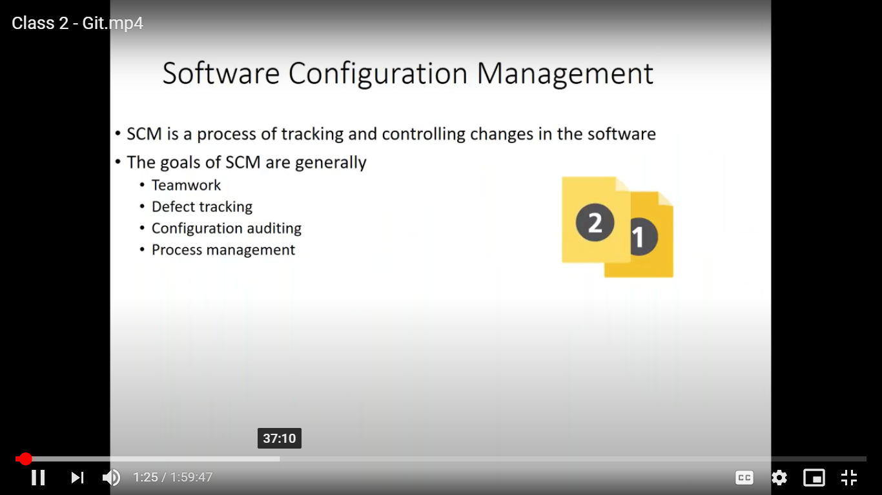

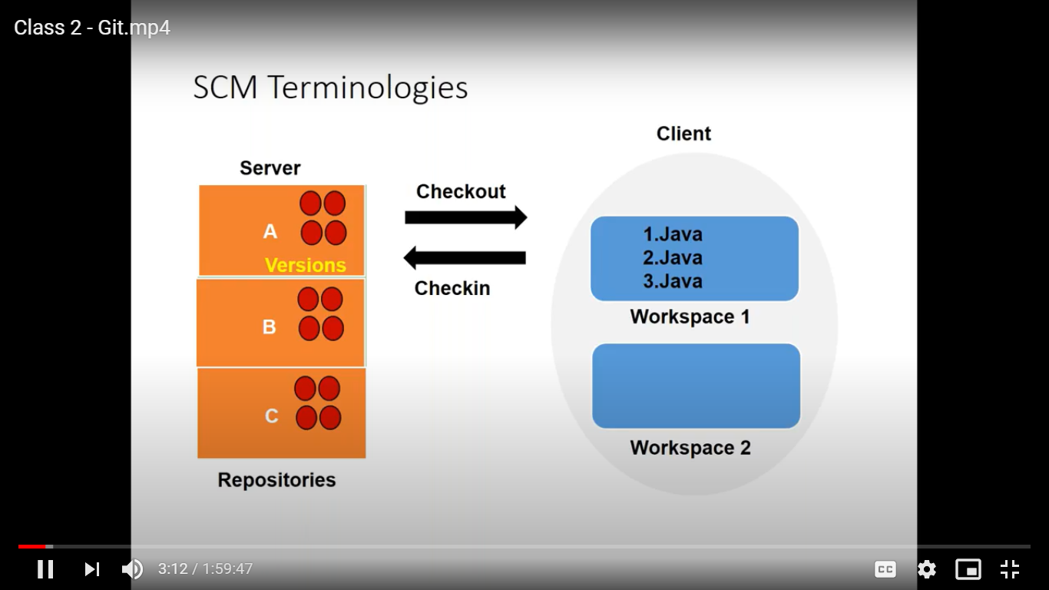

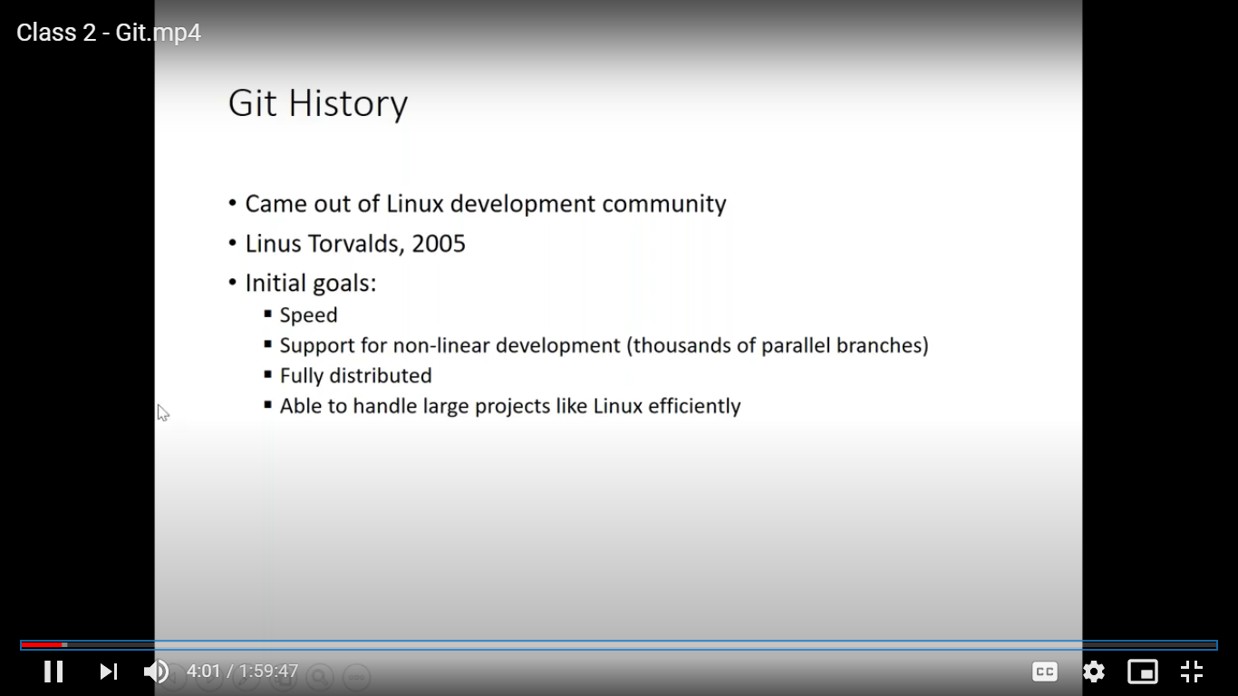

Distributed VS Centralized

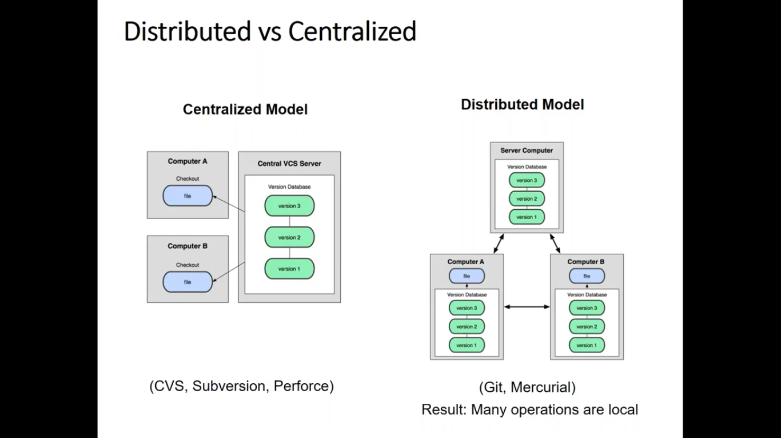

If we will have one server and from there only we have to checkout from it.

One common repository for everyone.

If server is located in other region like US and if you want to work from the central serval in us to your workspace.

Checkout means copy a file from a server to your machine.

And it will be huge files, to just checkout it requires 20 minutes.

If there is a network issue then it will be more slow.

If you want to transfer a changes to other person then there is only one way there we have to do checkin of files and from there only one needs to do checkout the files.

Since it is a common code then it should be a good code.

Then people has to go through a further testing.

Distributed Model.

In git there is no concept of server.

Workspace is nothing but a folder.

In git inside your workspace there will be repository.

Every workspace will have copy of repository inside it.

So it will take very less time to take checkout since repository will be inside the workspace.

Even you are not in the network checkout and checkin will happen fastly.

In git we will have 2 type of workspace.

Central workspace and local workspace.

Central workspace means it’s a common ws.

Any changes are you doing it will be available in same workspace.

Here we can share the changes between another person as well locally.

Checkout always happen with the repository what you have.

So take the latest changes we have to take update.

Workspace is nothing but a local folder that can be created as many as possible.

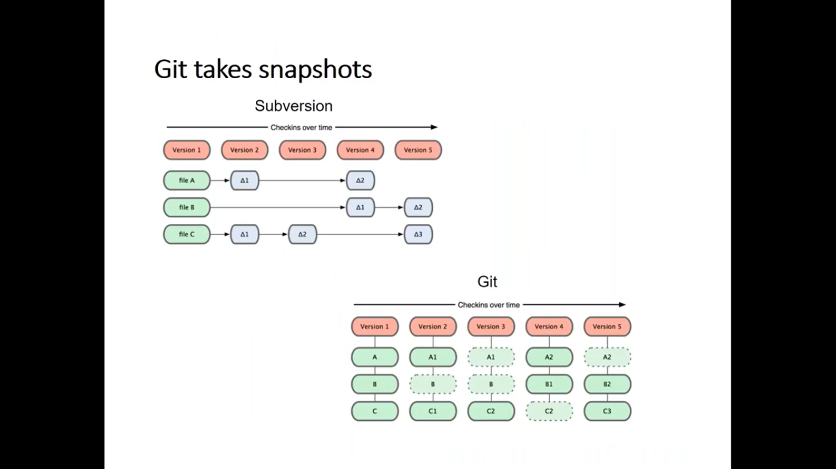

Repository is nothing but metadata.

In git only we have version.

Git takes snapshot, whatever we modified.

That is why it is very light weight.

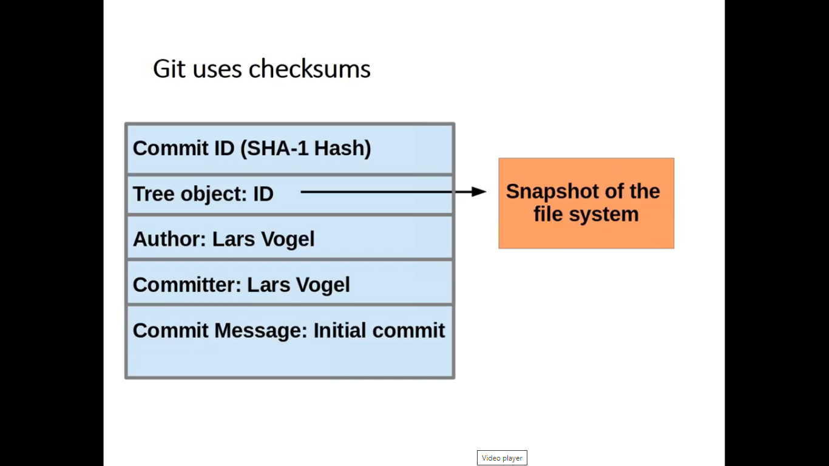

It will take all above details like author, commit message, timestamp and store it as version.

Every time while we commit we will get commit ID.

This is unique and it will be 40 characters and 64 bit.

While sharing from one repository to another repository that is nothing but a commit id.

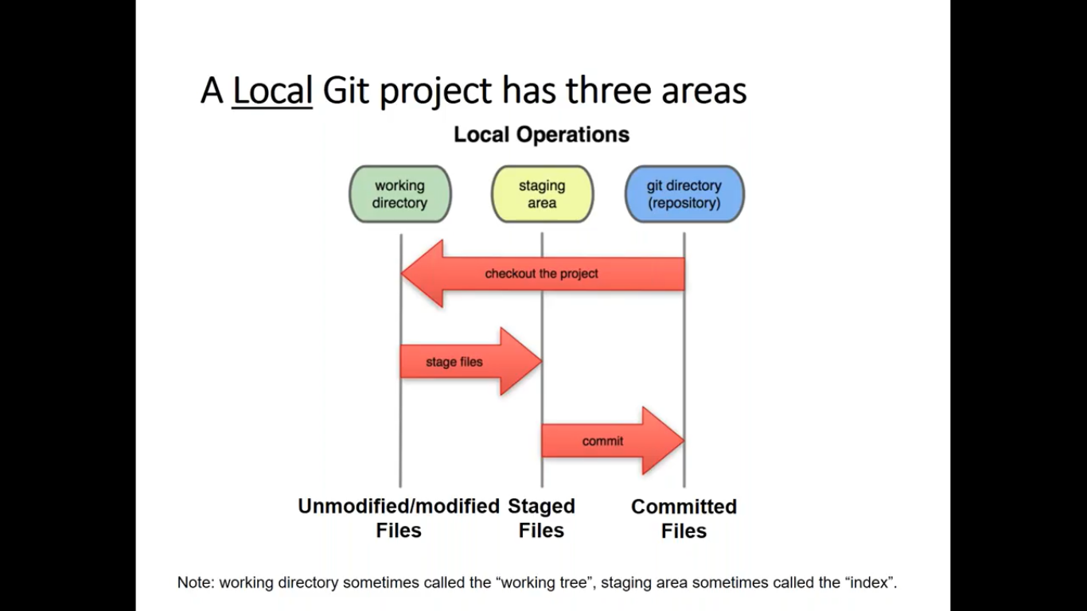

In git three areas we will have.

1. Working directory
2. Staging areas
3. Git directory(repository)

In git whatever checkin are we doing for that it has to go through 2 steps.

In staging area git will take the snapshots.

From git repository you will be sharing the commit id either to central repository or other repository.

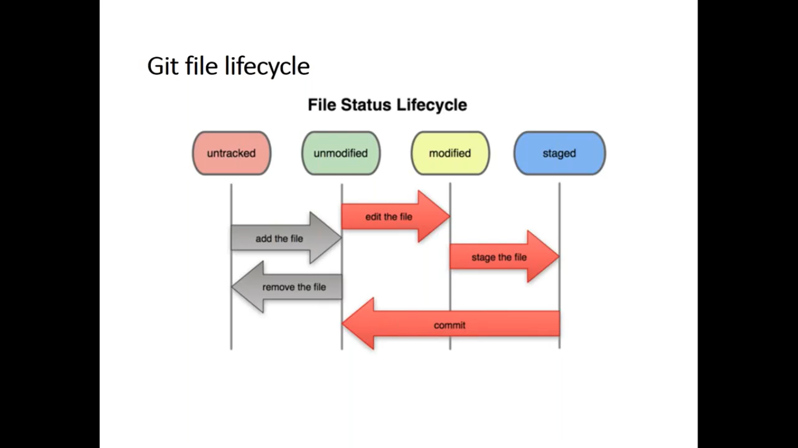

If you have a file that are not available in git repository then it is called as untracked files.

If it knows the file i.e. then it is called as tracked file here it is called as unmodified files.

Once you modified the file then it is called as modified file.

Then when you put it in staging area then it is called as staged file.

Local repo is also called as **non bare repo**(modify, storing & sharing)

Reason is that in your local ws, you will be modified, store and share the file.

Central repo is called as **bare repo(**storing & sharing) because here we should not go directly and modify the file.

Here we cannot modify the files.

All the activities which we will be doing via Git command only.

Central repository managers like github, gitlab which will manage the central repo.

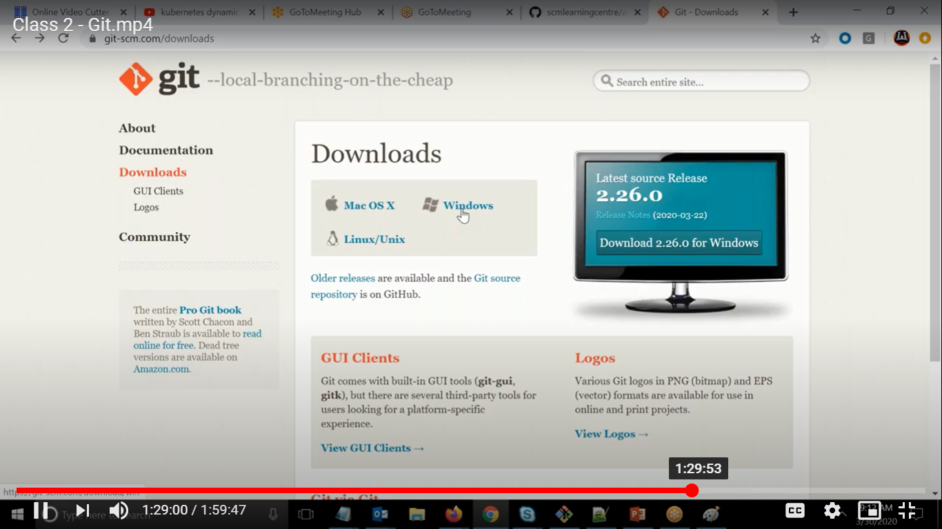

git version, here first one is called as executable and second one is called as arguments.

For running a configuration.

For all repository in one machine

git config –global user.name “Pankaj Jha”

git config – global user.email [jhapankaj69@gmail.com](mailto:jhapankaj69@gmail.com)

git config – global push.default “simple”

These are minimum values

If you want to do copy of central repository.

git clone <central-repo> <local-repo>

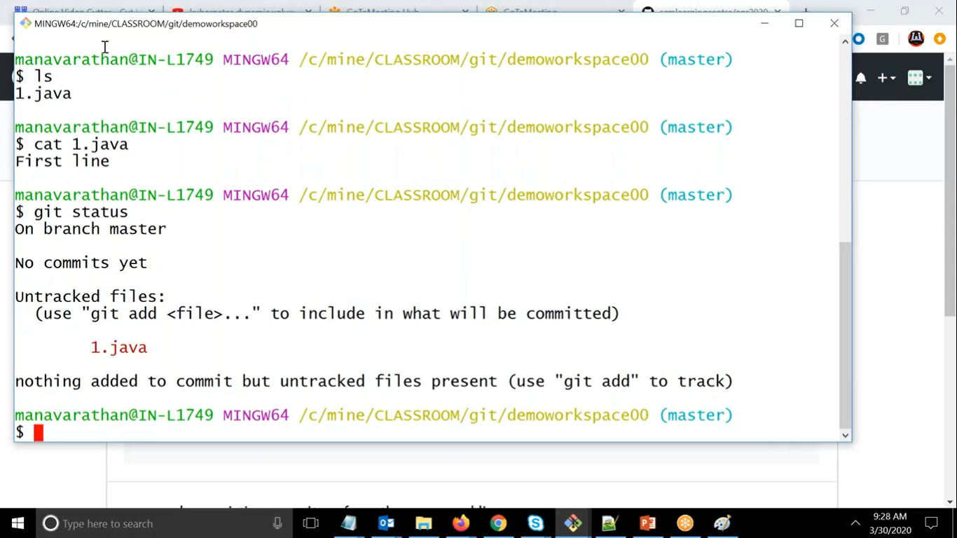

Here it is showing as untracked file since this file was not available in git directory.

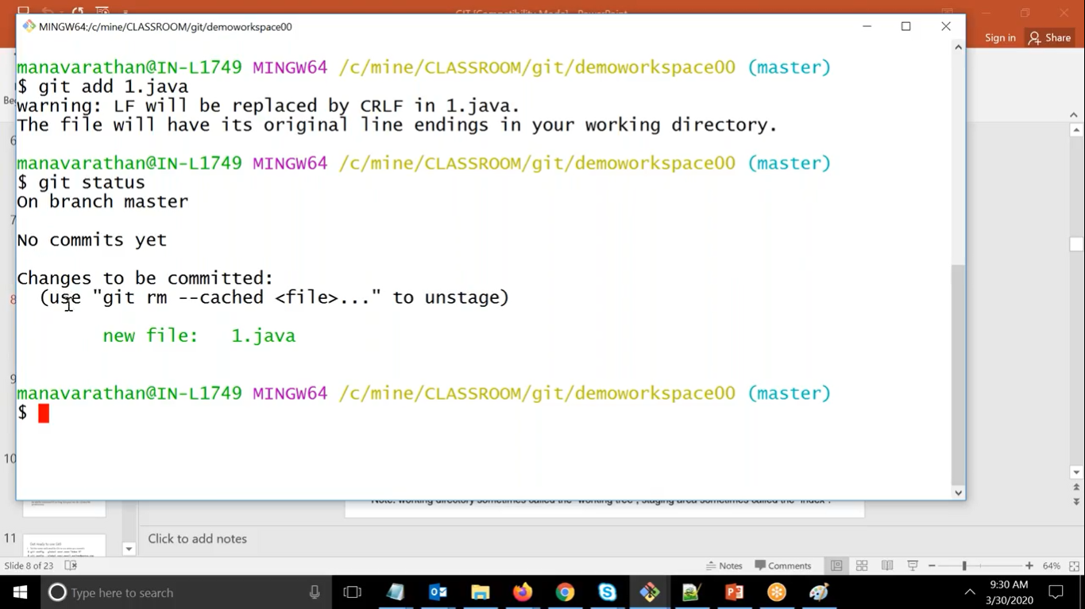

Now it is called as new file and available in staging area.

For second time while modifying it is called as modified file

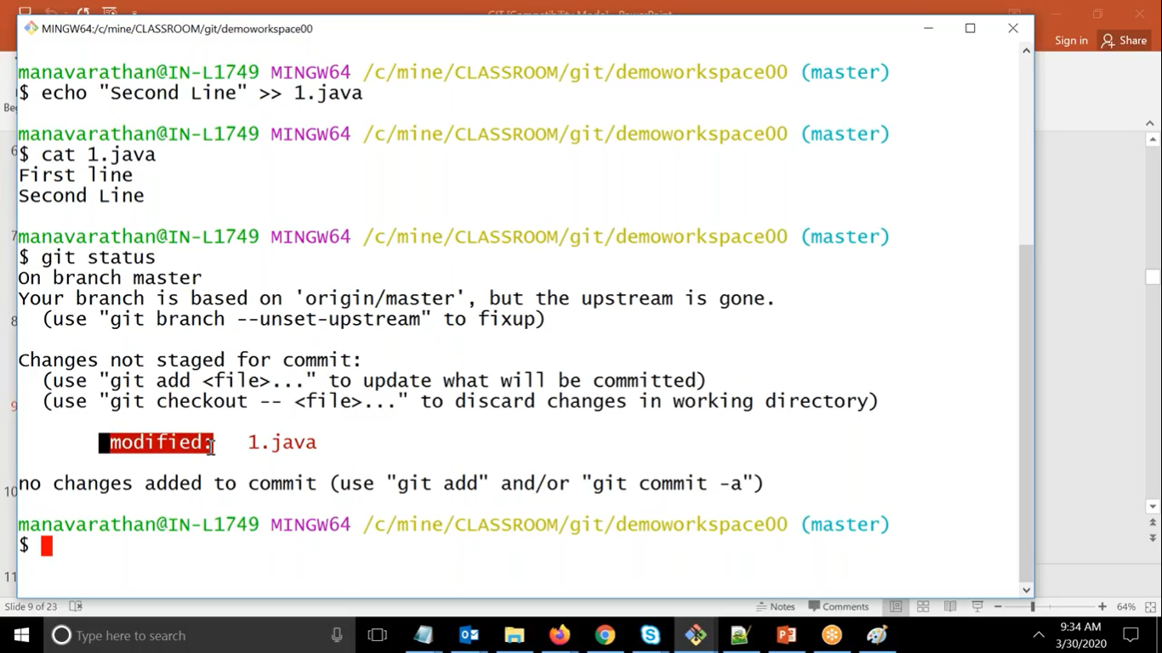

For checkin group of files we will put

git add .

For getting all the commit id we can use command.

git log

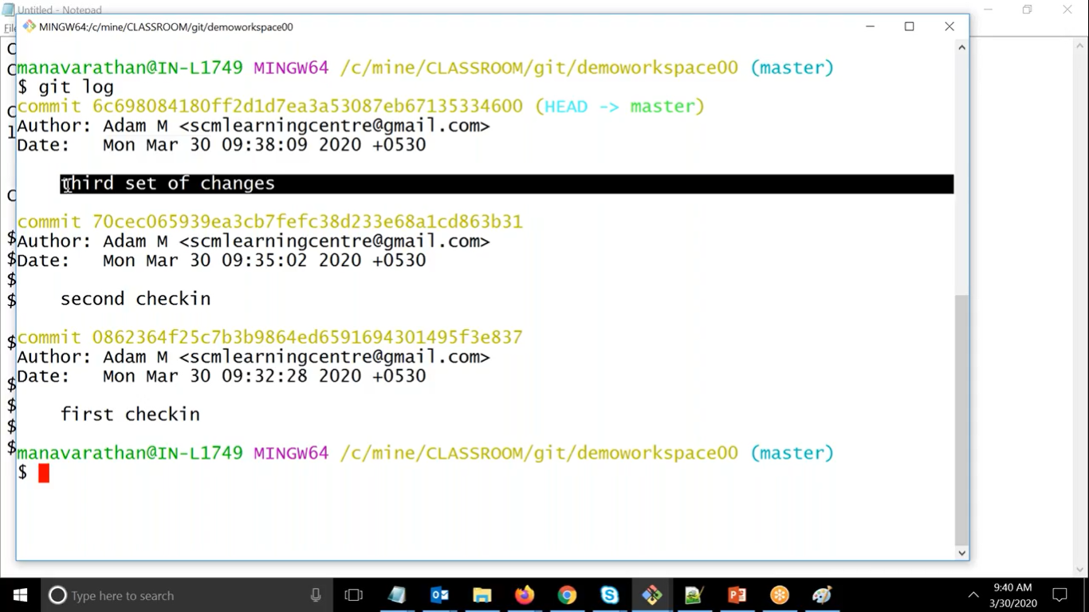

For getting logs in one line we can use

Git log –oneline

If want to see number of commit then we can use

Git log -1

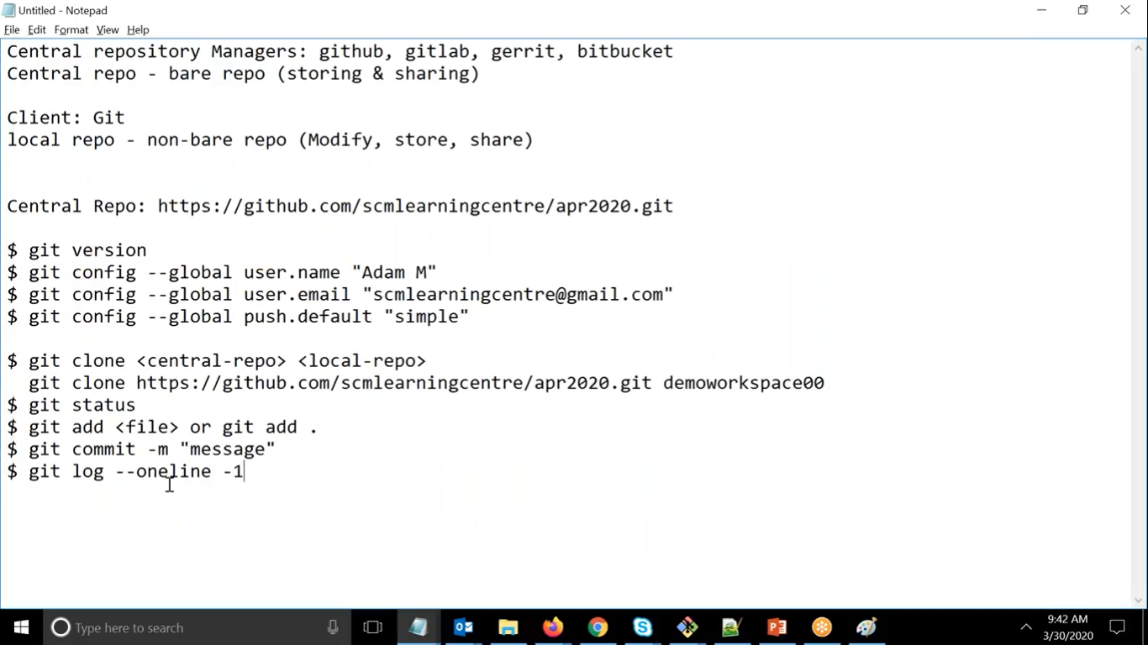

Why do we need Branches?

Because it is unique to the specific branch only..

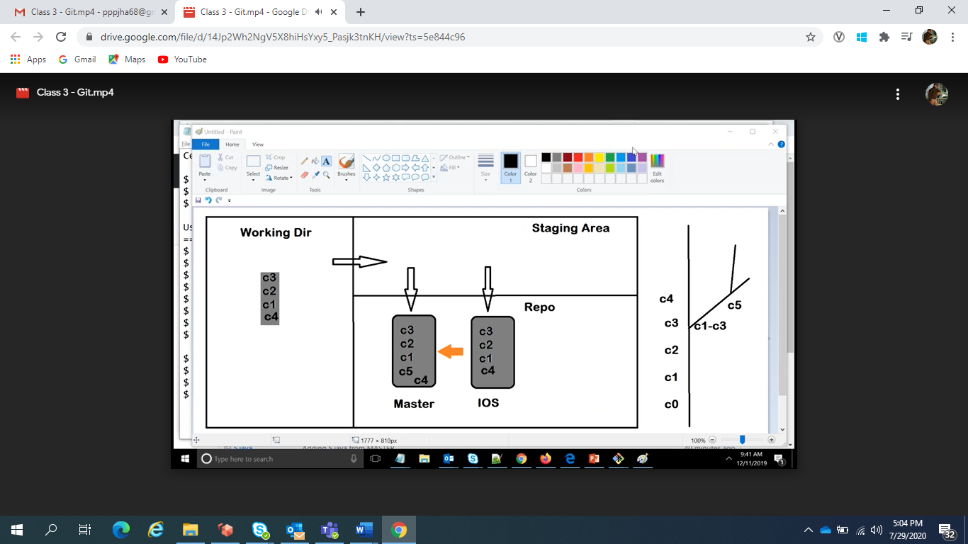

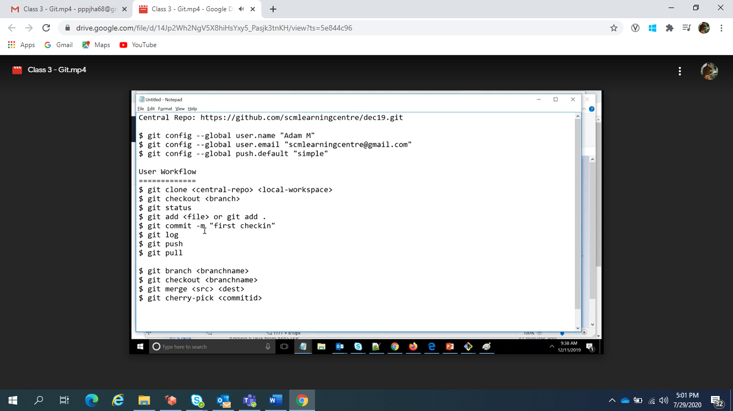

Merge is happening between two branches only

Head is nothing but pointer to commit id where are you working.

Head is the latest commit id

You are showing the content in working directory because head is refer to that commit id

If you are modifying any file in git it will reflect in all areas like staging and repository

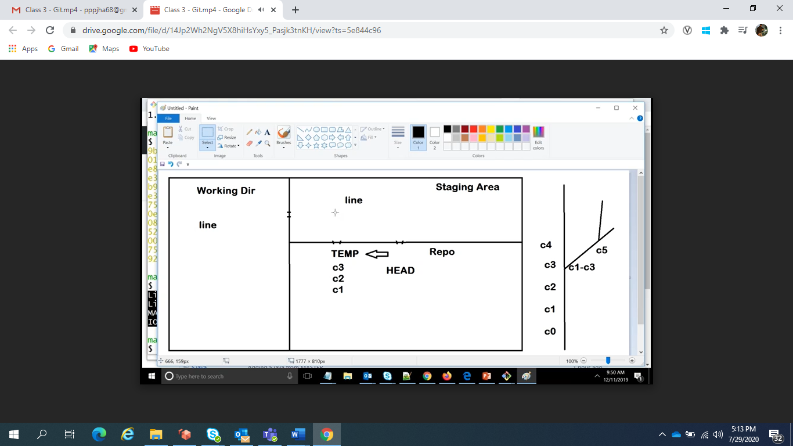

Temp reference in repo area

If you want to undo then from 3 areas we have to undo it.

Before you are going commit.

Three mode of reset.

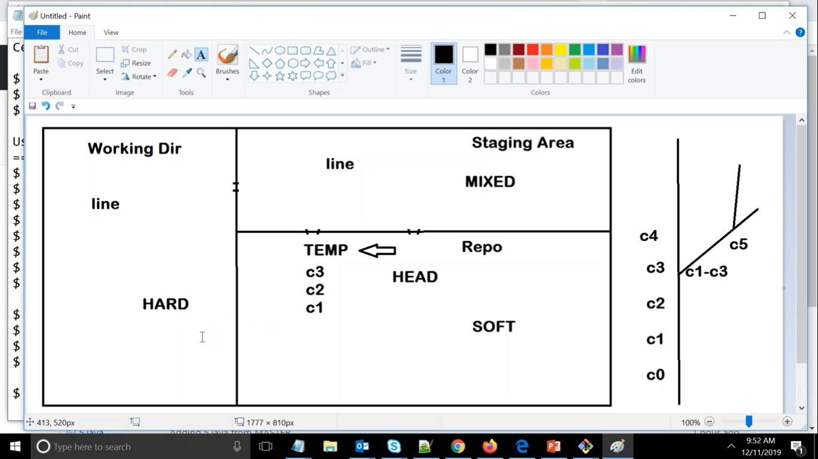

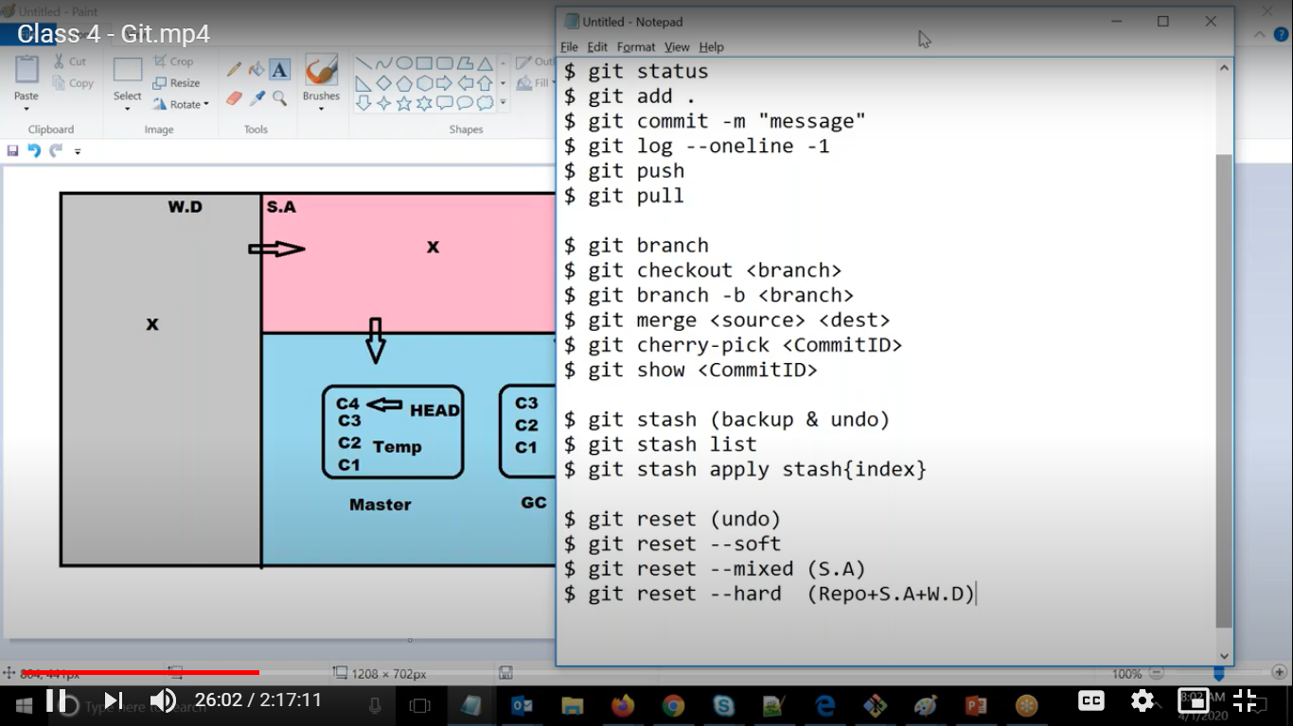

Git reset –soft( it will undo from repo area)

Git reset –mixed( it will undo from staging area and repo)

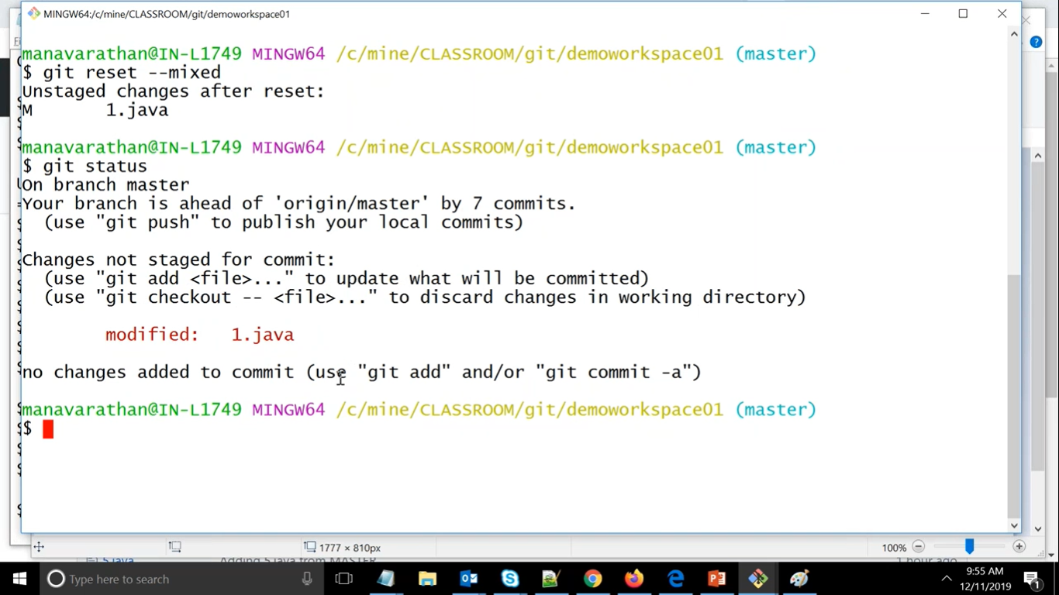

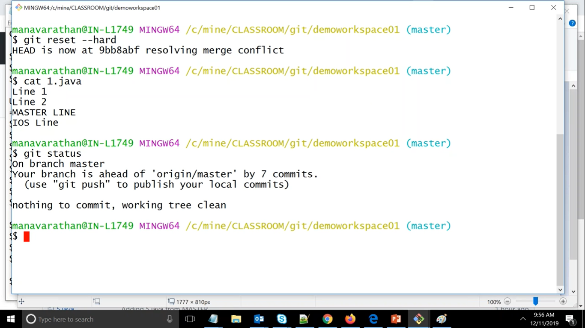

Git reset --hard means from all areas.

Reset will only undo

Stash will take backup and then undo

Reset will undo from all areas

Stash will undo from working directory

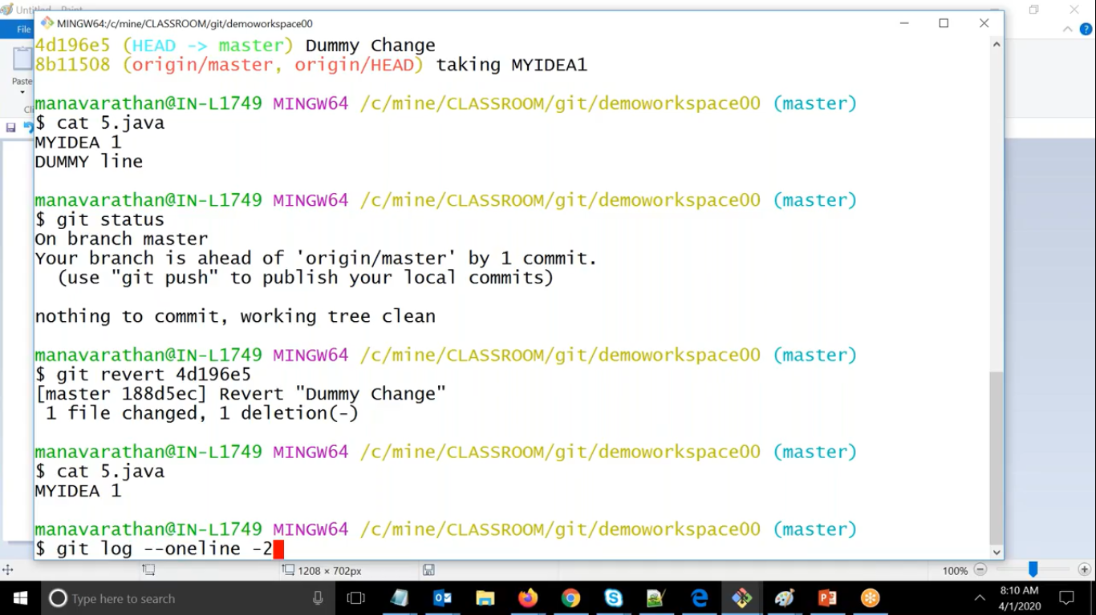

Here in git revert <commit id>

It will take the content back and move to previous commit id

In this way it will create one new commit id.

It will not delete the commit but on top of it it will take the content back and create new commit id

Scenerio :- **One day you have done some changes and push the changes to the central repository but latter any other developer commit his changes and when he tested the changes he found that his changes are not working with yours commit id so what he did revert your commit id and on next day when you try to test changes you find that your changes are reverted but now you want your changes so that in that changes only you will fix the code.**

**Solution :-** In this case you can go back to your commit id by using

**Here git checkout <commit id>**

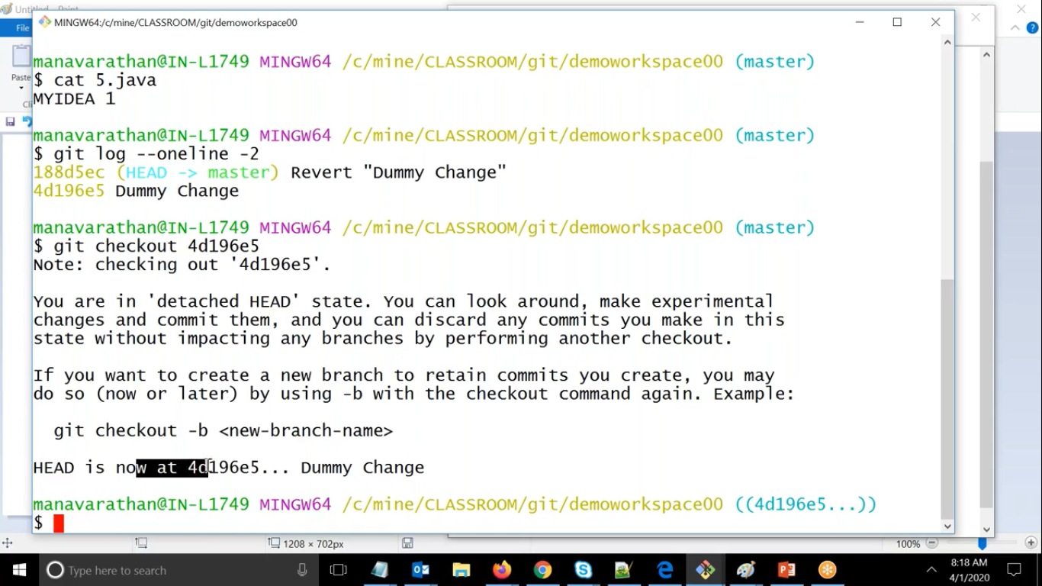

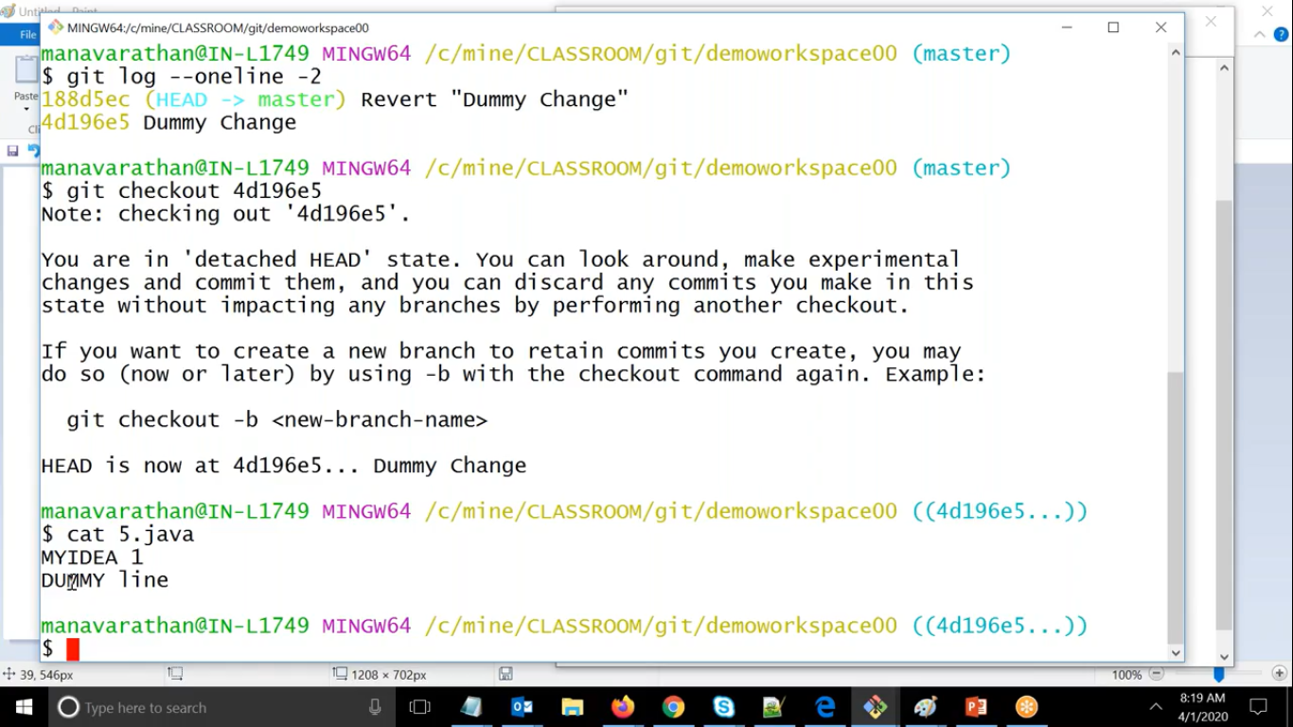

Scenerio:- **If we are from development background and if we want to deliver some deliverables and we want some file that should not be committed**

**Solution :- SO to ignore this files we can create one file called .gitignore and in this file we will add all files with extension .class to ignore it**

So it’s a good practice to commit this file in repo

Scenerio :- **If you want some file to remove for repository not from your working directory but also from repository.**

**Solution :- We can use git rm 5.java and we can add this deleted this file to staged directory and same we can push to commit.**

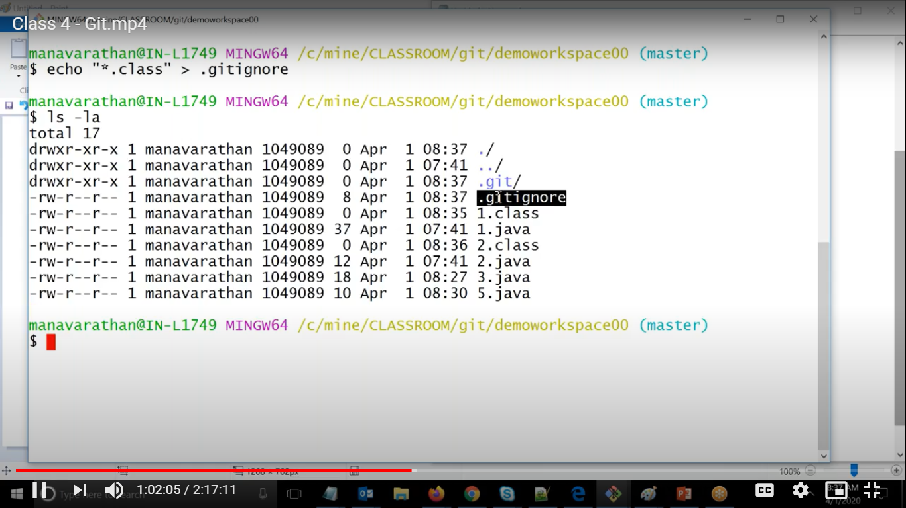

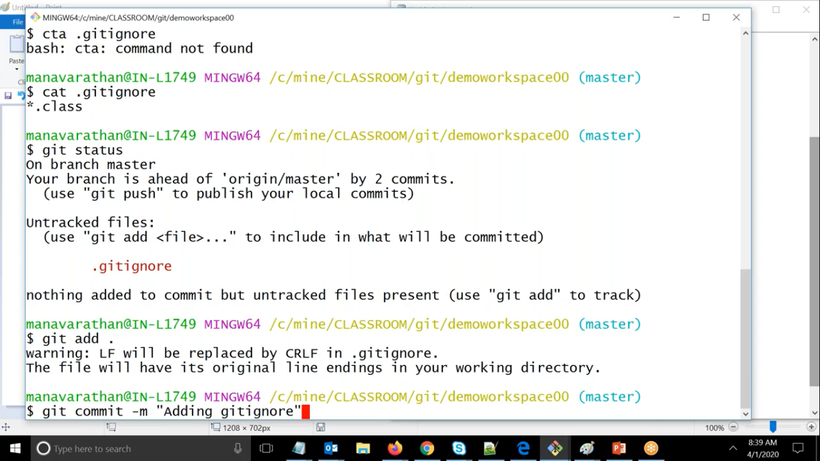

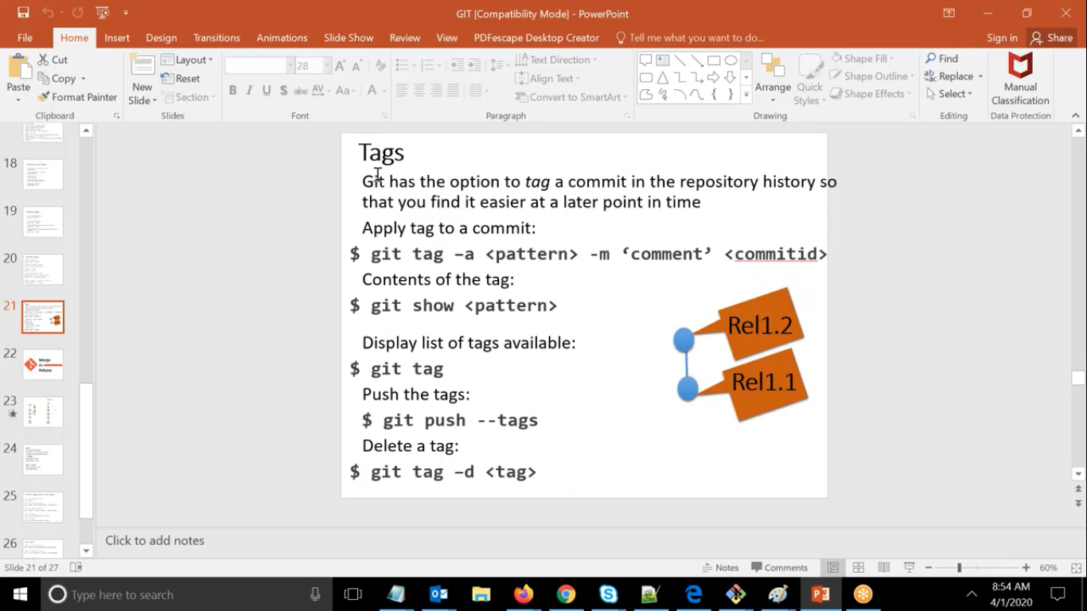

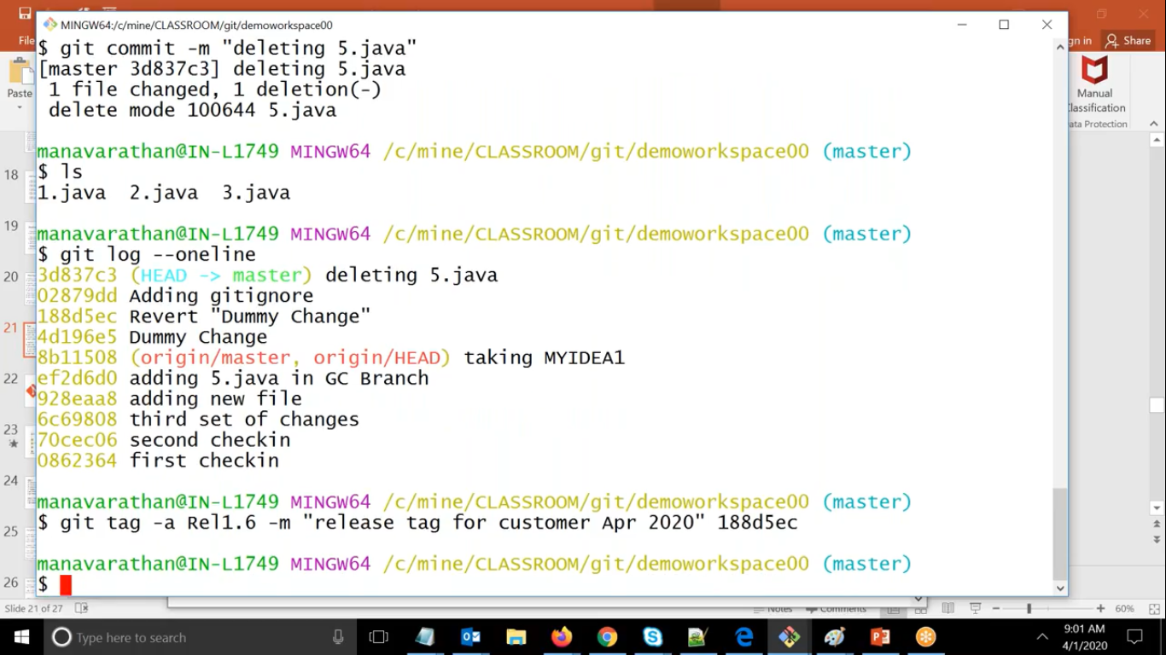

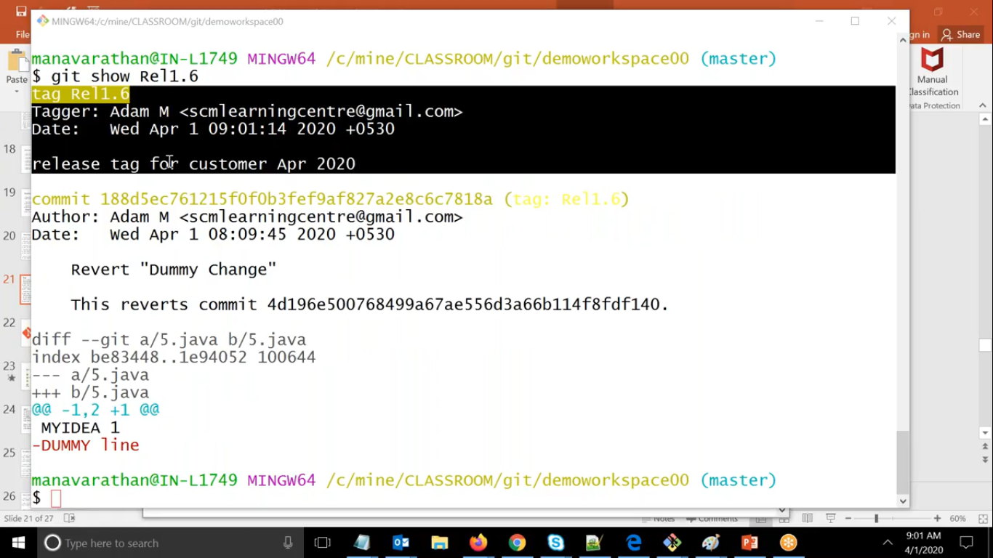

**Scenerio :- If you have many commit id but if want to go back to specific commit id.**

**Solution :-** We can use git tag.

**Here git tag -**a Rel1.2 -m “ This is change for Release 1.2”

**For showing changes to this tag**

Here git show Rel1.2

Here whatever tag are you creating this tag is for your working directory only.

But if you want to create tag for all then we can create it in central repository.

Note :- **Here in git one commit id can have multiple tag but one tag can only be associated with one commit id only**

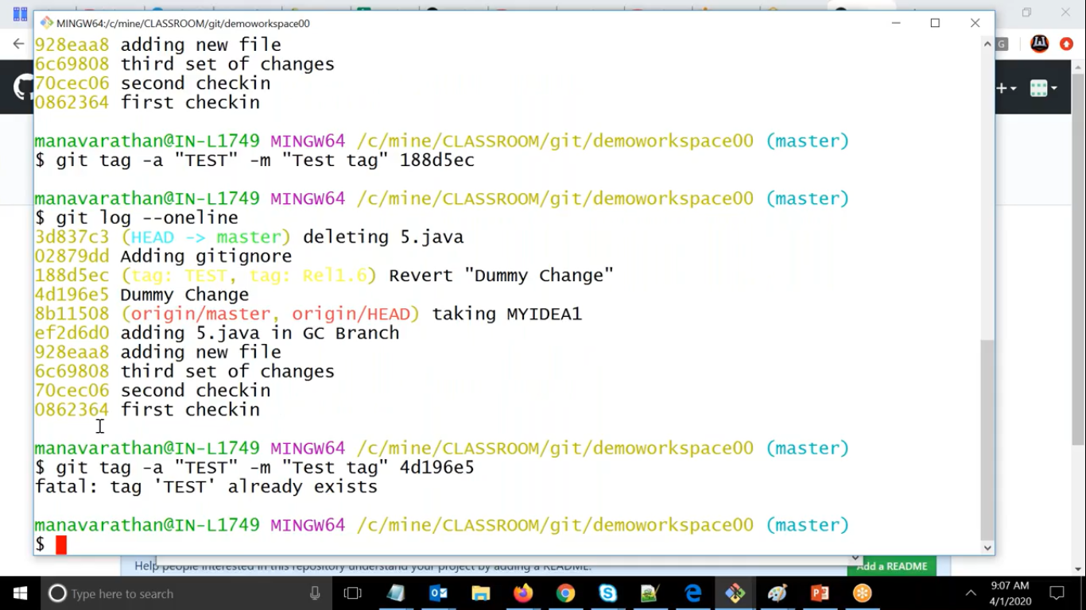

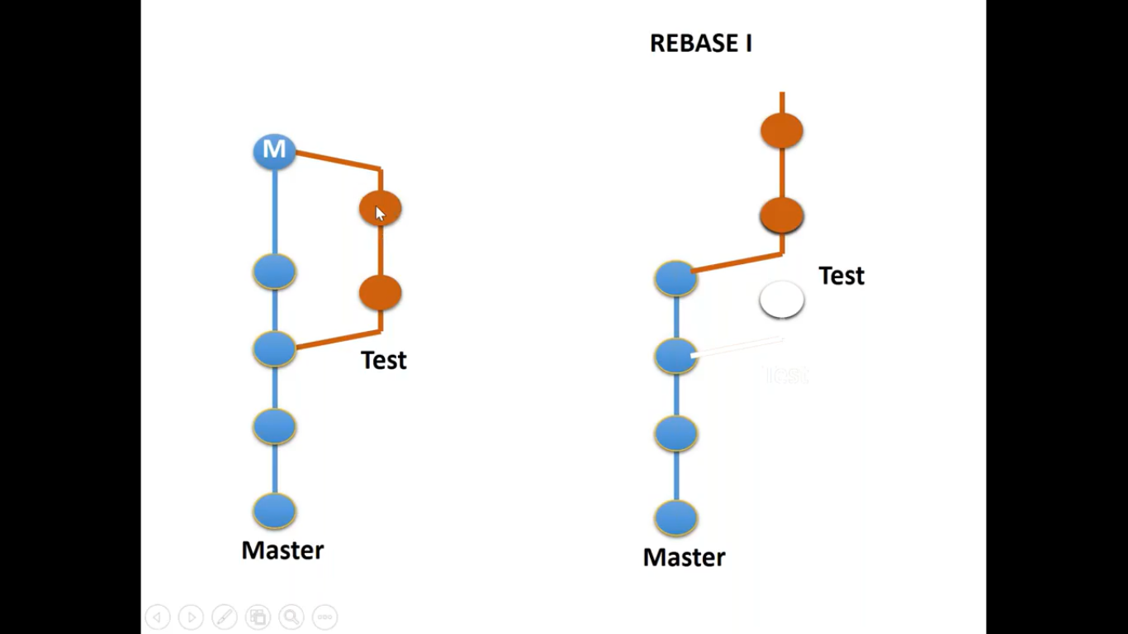

**If we do not many commit id as it will be more confusing then we can go for Rebase.**

**What it will do is it will realign the same branch as it will show that it is created from latest commit id.**

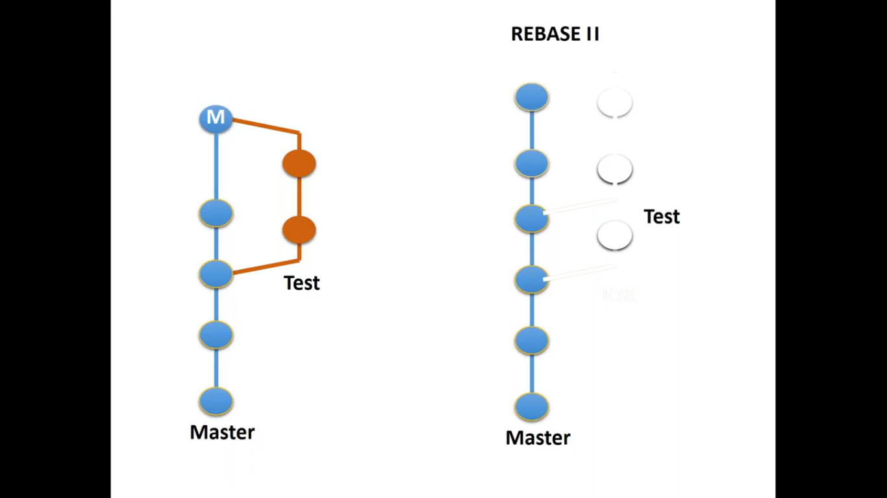

**If we want to rebase based on master branch.**

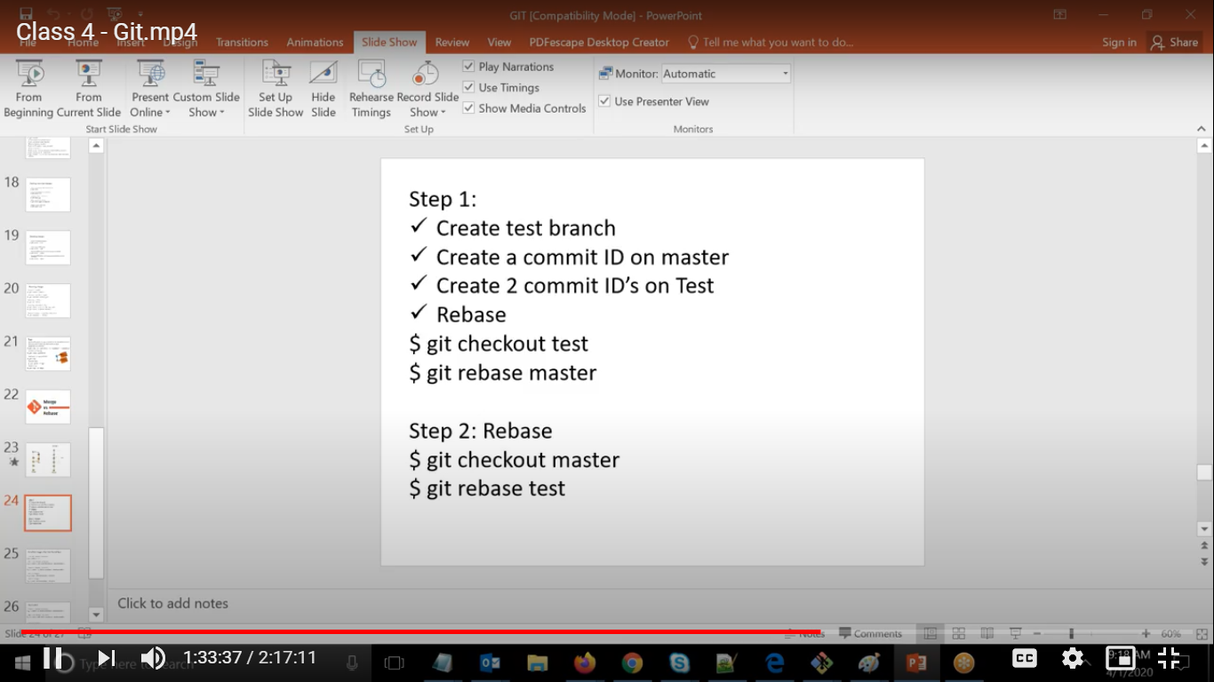

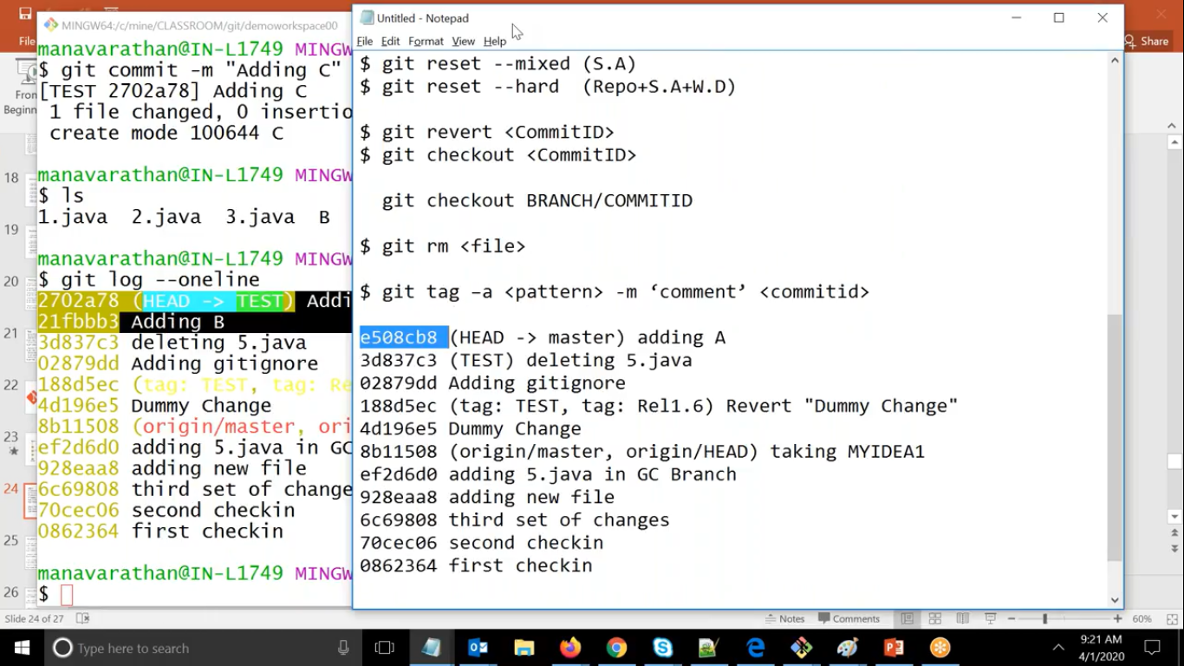

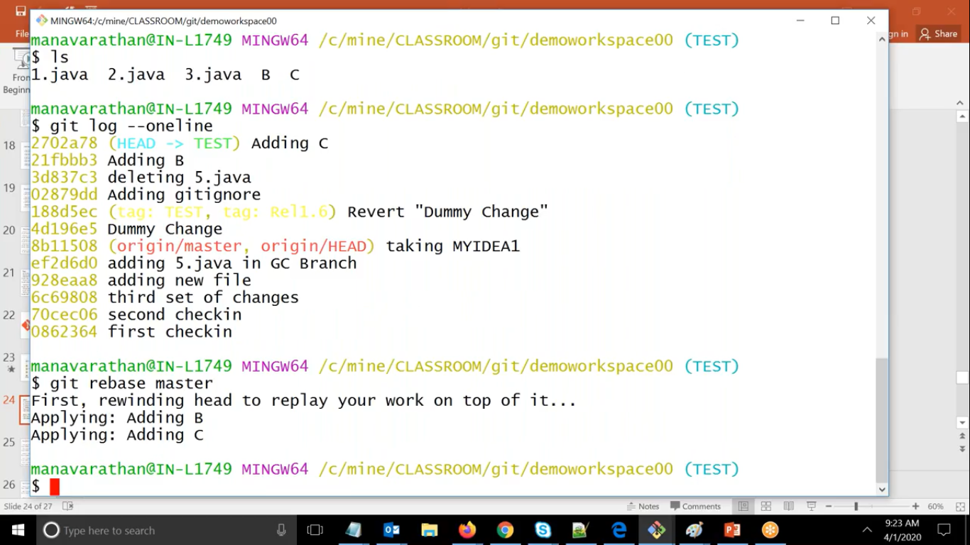

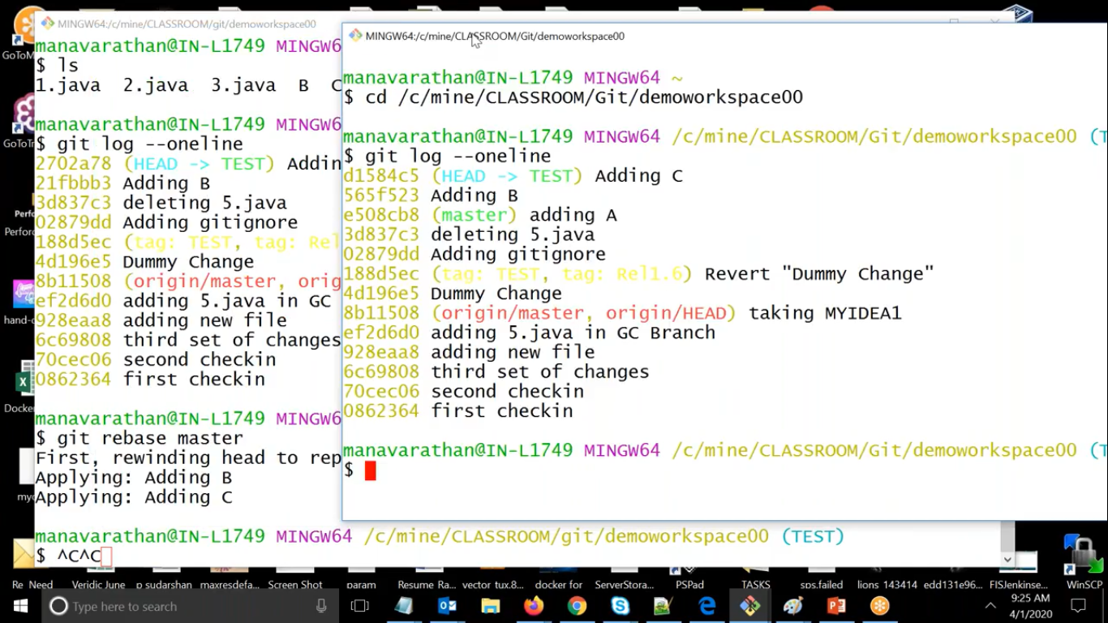

**Here We have created a new branch called test**

**And we have added files in it so here it is added from commit id c3**

**And if we do rebase test with reference to master**

**i.e. git rebase master**

**it will rewind the head and it will feel as we have created branch from latest commit id only, see in second pic**

**This Scenerio will be helpful when you have too many feature branches.**

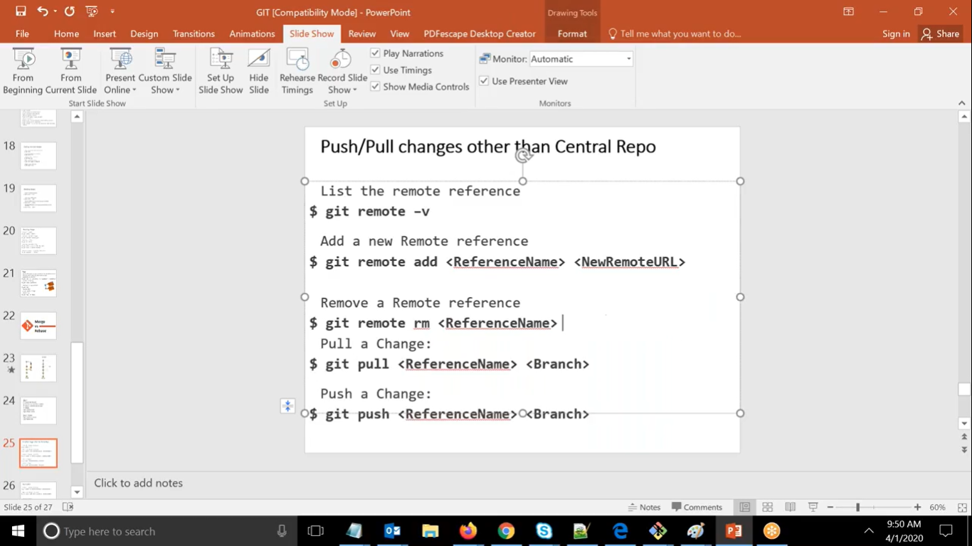

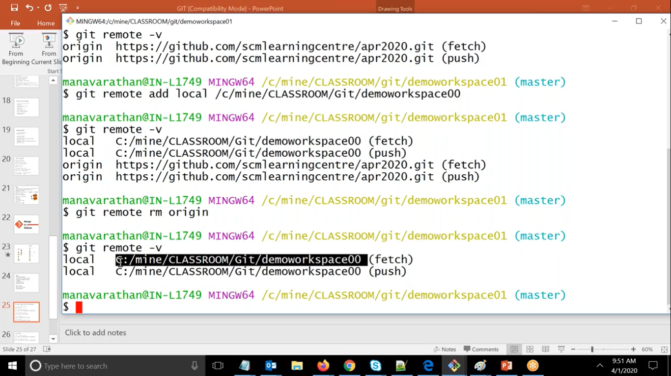

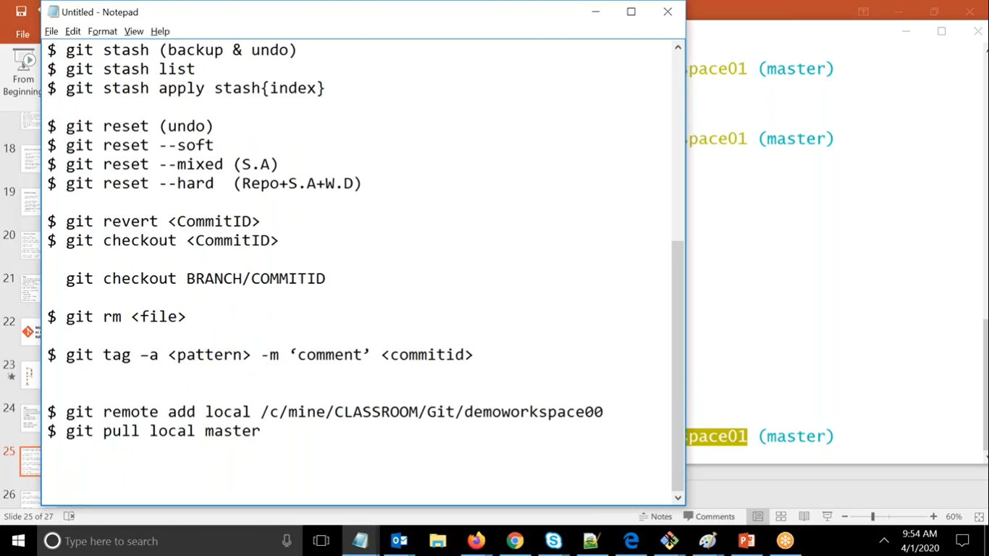

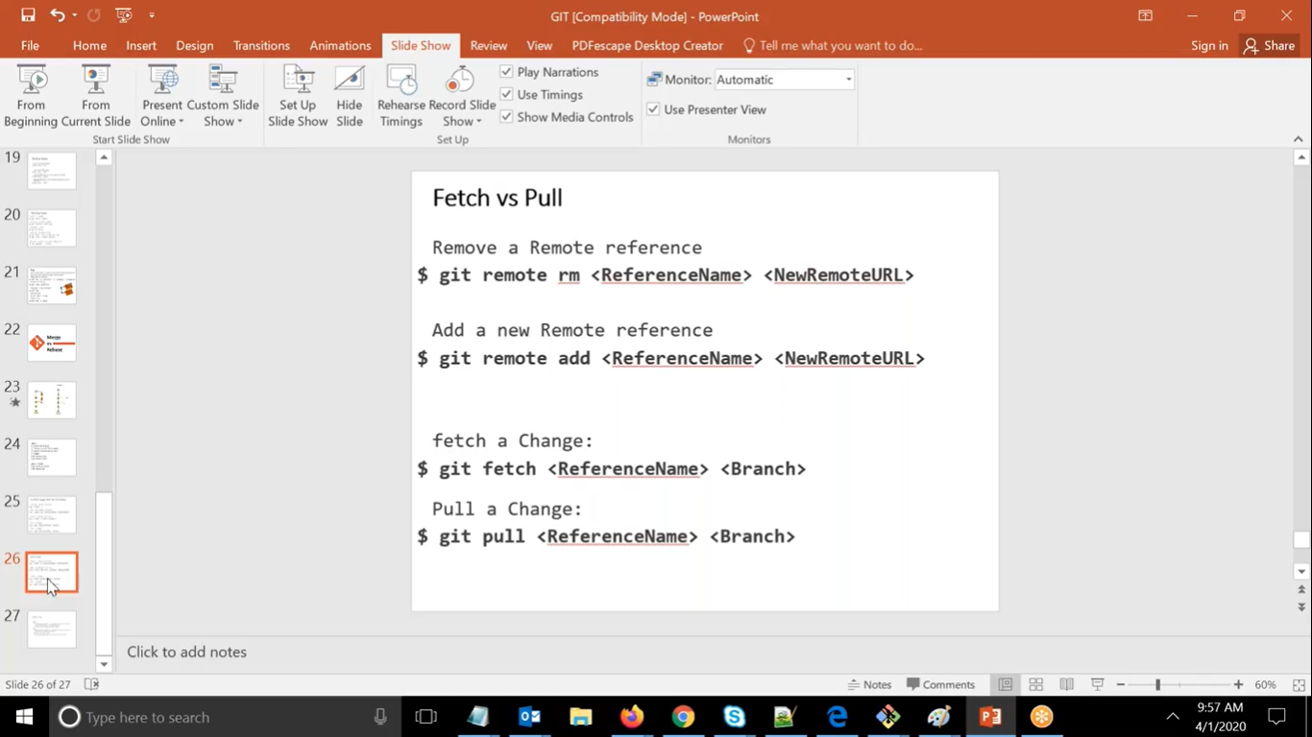

**Here git fetch means it will take the references only**

**But in git pull it will fetch along with it will realign the whole working directory.**

**Here git reference we can get the references and latter we can checkout it**

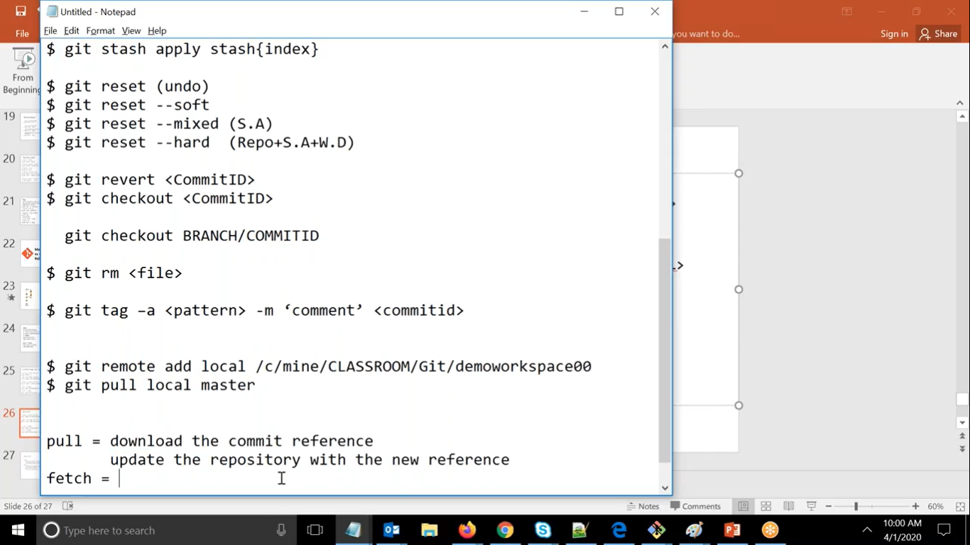

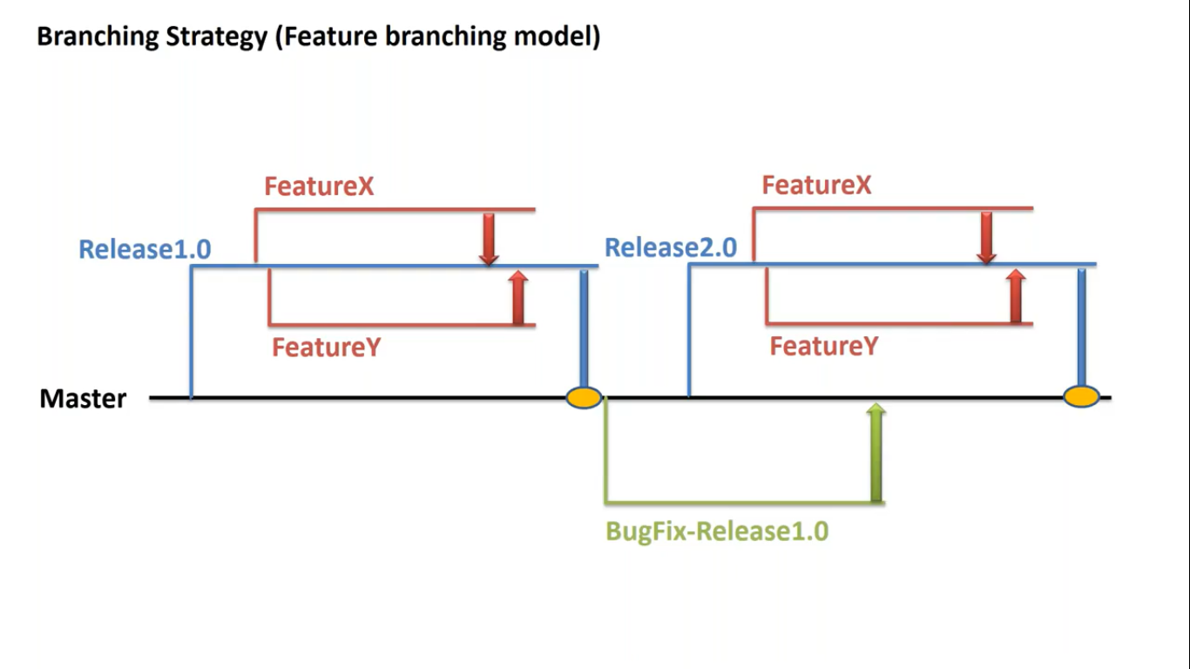

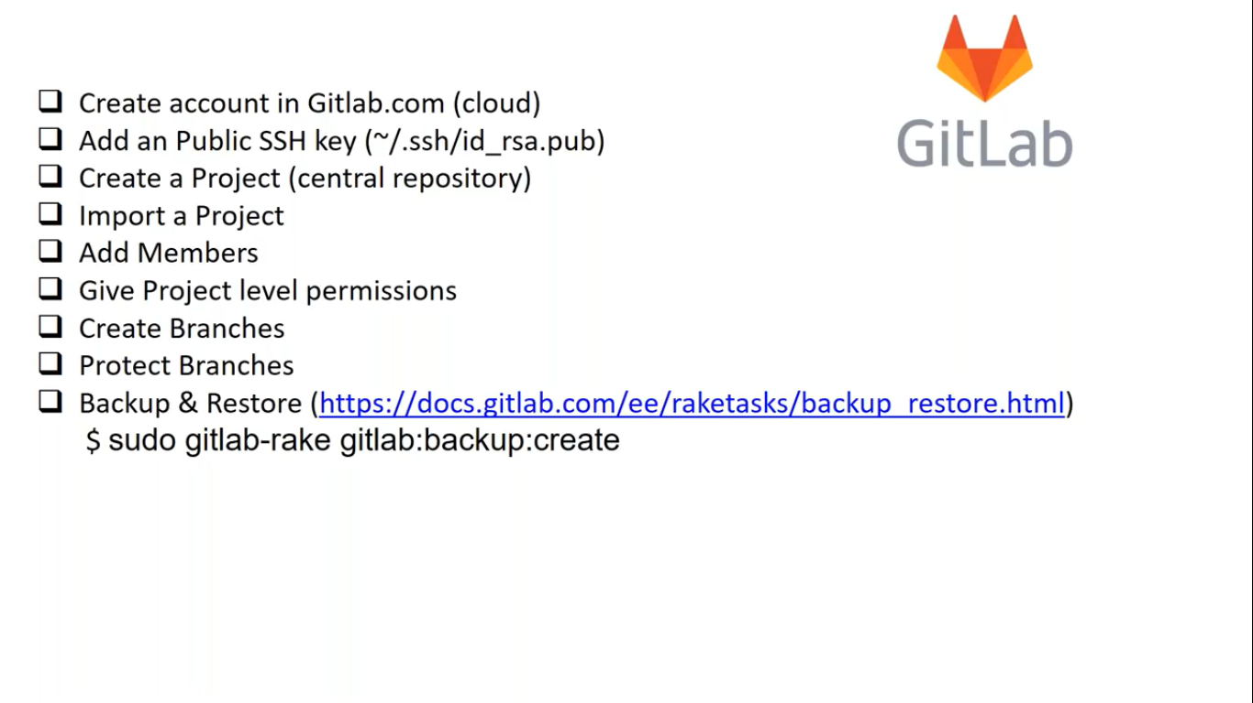

**In an organization even you have access to login gitlab but if it is marked as private you required permission to access any projects in it**